SUMMER TRAINING REPORT
ON
“ONLINE BOOK STORE”
At
Softpro India

Submitted In partial fulfilment of the requirements For the degree of
BACHELOR OF TECHNOLOGY
IN
COMPUTER SCIENCE AND ENGINEERING
By
Shruti Gupta
2206480100044
7th Semester
Under the Guidance of
Er. Rohit Kumar

Department of Computer Science and Engineering
Babu Sunder Singh Institute of Technology and Management Lucknow
(Campus: NH-24B Raibarely Road Nigohan Lucknow-226302)
Dr. A. P. J. Abdul Kalam Technical University, Lucknow
December, 2025

CERTIFICATE

This is to certify that Shruti Gupta (Roll No. 2206480100044), a student of B.Tech (Computer Science & Engineering), 7th Semester, Babu Sunder Singh Institute of Technology & Management, Lucknow, affiliated to Dr. A.P.J. Abdul Kalam Technical University, Lucknow, has successfully completed his Industrial Training on “Python Full Stack Development” at Soft Pro India Ltd. during the academic session-(2025-2026). The training work presented in this report is an original record of the work carried out by the student under my supervision and guidance. The report is found to be satisfactory and is approved for partial fulfillment of the requirements for the award of the Bachelor of Technology (B. TECH) degree.
I wish him every success in his future endeavors.

Signature of Faculty Guide Signature of HOD
Mrs. Suyogita Singh Mr.Hira Singh Yadav
Assistant Professor(CSE) Head of Department (CSE)

DECLARATION
I hereby declare that the industrial training report entitled “Python Full Stack Development” is an authentic and original record of the work carried out by me during my industrial training at Soft Pro India Ltd. This report has been prepared by me in partial fulfillment of the requirements for the award of the degree of Bachelor of Technology (B.Tech) in Computer Science and Engineering from Babu Sunder Singh Institute of Technology & Management, Lucknow, affiliated to Dr. A.P.J. Abdul Kalam Technical University, Lucknow. I further declare that the information, data, code, screenshots, diagrams, and explanations presented in this training report are based on my own learning, practical exposure, and understanding gained during the training period. The matter embodied in this report has not been copied from any source, book, website, or report, except where due reference has been made in the bibliography. Any similarity with existing work is purely coincidental and unintentional. I also affirm that this training report has not been submitted earlier to any university, institute, or organization for the award of any degree, diploma, or certification. All guidance received from my faculty guide, trainers, and mentors during the training period has been duly acknowledged. The conclusions and outcomes presented in this report are based solely on my individual efforts and learning experiences during the training program.
I take full responsibility for the originality, authenticity, and correctness of the content presented in this report. If any part of this report is found to be plagiarized or incorrect, I shall be solely responsible and liable for any academic or disciplinary action as per the rules and regulations of the university or institute.

Shruti Gupta
(2206480100044)

ACKNOWLEDGEMENT
I would like to express my sincere gratitude to all those who have contributed directly or indirectly towards the successful completion of my industrial training and the preparation of this training report entitled “Python Full Stack Development.” First and foremost, I am extremely thankful to the management and training team of Soft Pro India Ltd. for providing me the opportunity to undergo industrial training in such a professional and learning-oriented environment. I would like to extend my heartfelt thanks to my industry mentor and trainers at Soft Pro India Ltd. for their valuable guidance, constant encouragement, and technical support throughout the training period. Their practical insights, real-time problem-solving approach, and industry-level exposure have significantly enhanced my technical knowledge and professional skills. I express my deep sense of gratitude to my faculty guide for his/her continuous guidance, constructive suggestions, and motivation during the training period and while preparing this report. The timely feedback and academic support provided by my faculty guide played a crucial role in shaping this training report in its present form. I am also thankful to the Head of the Department, Computer Science & Engineering, Babu Sunder Singh Institute of Technology & Management, Lucknow, for providing a supportive academic environment and necessary facilities to complete this industrial training successfully.
I would like to acknowledge my sincere thanks to all the teaching and non-teaching staff members of the institute for their cooperation and support. Finally, I express my heartfelt gratitude to my parents and friends for their constant encouragement, moral support, and motivation throughout the training period and academic journey.

Shruti Gupta
(2206480100044)

ABSTRACT
This training report presents a comprehensive overview of the industrial training and practical exposure gained during the Python Full Stack Development training undertaken at Soft Pro India Ltd. The primary objective of this industrial training was to bridge the gap between theoretical knowledge acquired during the academic curriculum and the practical requirements of the software industry. The training was designed to enhance technical proficiency, problem-solving ability, and professional skills required for realworld software development. During the training period, various core concepts of Python programming were covered, including data types, control structures, functions, objectoriented programming, exception handling, and file handling. Along with Python, frontend technologies such as HTML, CSS, and JavaScript were learned to design interactive and responsive user interfaces. Backend development was carried out using Python frameworks such as Django/Flask, where concepts like URL routing, templates, form handling, authentication, and basic REST APIs were implemented. The training also included hands-on experience with database management systems like MySQL/PostgreSQL, focusing on database design and CRUD operations. Industrystandard tools such as Visual Studio Code, Git, GitHub, and Postman were used during development and testing. As a part of the training, a project was developed using Python Full Stack technologies, which provided exposure to the software development life cycle (SDLC) including requirement analysis, development, testing, and documentation. This industrial training enhanced technical skills, problem-solving ability, and professional confidence, and will be helpful for future academic projects and career growth.

TABLE OF CONTENT
S. No. Title Page No.
Certificate i
Declaration ii
Acknowledgement iii
Abstract iv

Table of Contents v
List of Figures/Tables/Abbreviations vi
Chapter 1: Introduction 7
Chapter 2: Company Profile 11
Chapter 3: Methodology 17
Chapter 4: Project Work 27
Chapter 5: Results & Discussion 34

 | LIST OF FIGURES
Figure No. | Figure Title | Page No.
Figure 2.1 | Organizational Structure of Soft Pro India Ltd. | 6
Figure 3.1 | Python Full Stack Architecture Diagram | 11
Figure 4.1 | System Architecture of Project | 19
Figure 4.2 | Project Home Page Screenshot | 51
Figure 4.3 | User Login Page | 51
Figure 4.4 | Admin Dashboard Screenshot | 52
Figure 4.5 | Database Schema Diagram | 52
Figure 5.1 | Final Project Output Screen | 53

CHAPTER 1 INTRODUCTION

1.1 Overview of the IT Industry
The Information Technology (IT) industry has become one of the most significant contributors to the global economy. IT encompasses a broad range of services, including software development, web and mobile applications, cloud computing, cybersecurity, artificial intelligence, and data analytics. Over the past decades, IT has shifted from being a supportive function to a key driver of innovation, business efficiency, and global connectivity. Organizations now rely on IT solutions to optimize operations, enhance customer experiences, and maintain a competitive edge.
Globally, the IT industry continues to grow at a rapid pace, with demand for software and technology solutions rising every year. India, in particular, has emerged as a hub for IT services, with cities like Bangalore, Hyderabad, Pune, and Gurugram hosting major IT companies, start-ups, and innovation centers. The “Digital India” initiative, growing internet penetration, and increasing adoption of cloud technologies have accelerated digital transformation across sectors. This has created a surge in demand for skilled IT professionals who can develop, maintain, and innovate technology solutions.
Key drivers of the IT industry include emerging technologies such as artificial intelligence (AI), machine learning (ML), cloud computing, and the Internet of Things (IoT). Agile development methodologies and DevOps practices have revolutionized software delivery, ensuring rapid deployment, continuous integration, and high-quality solutions. Additionally, the rise of remote work has broadened the global talent pool, allowing IT companies to hire skilled professionals from across the world.

Evolution of Web Development
Web development has transformed significantly since the advent of the internet. Initially, websites were static, serving primarily as informational platforms. Over time, with advancements in programming and browser technologies, web applications became dynamic, interactive, and user-centric. The growth of e-commerce, online banking, education portals, and social media has fueled the demand for robust, scalable, and secure web applications.
Web development has transformed significantly since the advent of the internet. Initially, websites were static, serving primarily as informational platforms. Over time, with advancements in programming and browser technologies, web applications became dynamic, interactive, and user-centric. The growth of e-commerce, online banking, education portals, and social media has fueled the demand for robust, scalable, and secure web applications.
The front-end focuses on creating interactive and responsive interfaces using HTML, CSS, and JavaScript, along with frameworks like React, Angular, and Vue.js. The backend handles server-side operations, database interactions, API integrations, and business logic, using languages and frameworks such as Python with Django or Flask, Node.js, and Java with Spring. Full stack development also requires knowledge of databases (SQL and NoSQL), version control systems (Git), and deployment platforms.

Python Full Stack Development
Python Full Stack Development has become highly popular due to Python’s simplicity, readability, and versatility. Python is widely used for both back-end development and scripting, making it ideal for full stack applications. Frameworks like Django and Flask provide robust tools for building scalable web applications, handling database management, authentication, routing, and API integrations.
Django is a high-level Python framework that follows the Model-View-Template (MVT) architecture. It is designed for rapid development and clean, pragmatic design, providing built-in features for security, authentication, and scalability. Flask, on the other hand, is a lightweight micro-framework that allows developers to build applications with greater flexibility and minimal boilerplate code. Both frameworks integrate seamlessly with front-end technologies, enabling developers to create full-featured applications.
Front-end development in Python full stack involves working with JavaScript, HTML, CSS, and libraries like React or Vue.js. Knowledge of front-end frameworks ensures that applications are responsive, interactive, and visually appealing. Additionally, full stack developers must handle database operations, often using PostgreSQL, MySQL, or MongoDB, and deploy applications on cloud platforms such as AWS, Google Cloud, or Heroku.

Significance of Python Full Stack Development
Python Full Stack Development plays a crucial role in modern software engineering. Organizations prefer Python developers because they can handle multiple aspects of web application development, from designing the interface to managing server-side logic. This reduces dependency on multiple specialized teams, shortens development timelines, and lowers costs.
Full stack developers bring a holistic view of applications, ensuring better integration, optimized performance, and enhanced security. Their skills are valuable for start-ups, small businesses, and large enterprises alike. They can rapidly prototype applications, test new features, and implement business logic efficiently.
Python’s popularity in data analytics, AI, and machine learning also adds value to full stack development. Developers can integrate AI-driven functionalities such as chatbots, recommendation systems, and predictive analytics directly into applications, increasing their market relevance.

1.5 Trends in Python Full Stack Development
Python full stack development is continuously evolving. Some major trends include:
- Cloud-Native Applications: Python applications are increasingly being deployed on cloud platforms, enabling scalability and global accessibility.
- Microservices Architecture: Applications are being built as independent, loosely coupled services, improving maintainability and deployment speed.
- Integration with AI & ML: Python’s strong ecosystem in AI/ML allows full stack developers to add intelligent features to applications.
- DevOps Practices: Continuous integration and continuous deployment (CI/CD) streamline development and reduce errors.
- Security & Performance: Increased focus on securing applications against cyber threats and optimizing performance for better user experience.
Developers are expected to continuously learn new technologies, frameworks, and deployment strategies to stay relevant in the industry

CHAPTER 2
COMPANY PROFILE

2.1 Company Overview
SoftPro India Ltd is a leading Information Technology company headquartered in India, specializing in software development, IT consulting, and digital transformation solutions. The company focuses on delivering innovative, cost-effective, and high-quality technology solutions to clients across diverse sectors such as healthcare, finance, education, retail, and e-commerce. SoftPro India Ltd is known for its client-centric approach, which ensures solutions are aligned with business objectives and industry standards. The company provides end-to-end IT services, including web and mobile application development, full stack development using Python, cloud computing solutions, artificial intelligence (AI) integration, and maintenance support.
With a team of highly skilled professionals, SoftPro India Ltd emphasizes innovation, quality, and operational excellence. Its robust portfolio of solutions and services has made it a trusted IT partner for organizations seeking to optimize their operations, enhance digital capabilities, and achieve competitive advantage.

2.2 History of SoftPro India Ltd
SoftPro India Ltd was founded in with a vision to deliver efficient and reliable IT solutions to small and medium-sized enterprises. Initially, the company started with a small team of software developers providing customized software solutions. Over the years, it expanded its capabilities to cater to larger organizations and international clients.

Key Milestones in Company History
- Foundation: Launched with a focus on bespoke software development and local business solutions.
- Service Expansion: Added web development, mobile app development, and IT consulting services to meet market demands.
- Adoption of Modern Technologies: Integrated Python full stack development, AI, machine learning, and cloud-based solutions into the product portfolio.
- Global Presence: Established partnerships with international clients and expanded operations to deliver scalable IT solutions across borders.
- Recognition & Awards: Received industry recognition for excellence in service delivery, innovation, and client satisfaction.
SoftPro India Ltd has maintained a strong focus on continuous learning, innovation, and customer satisfaction, contributing to its steady growth and reputation in the IT industry.

2.3 Products and Services
SoftPro India Ltd offers a comprehensive range of IT products and services designed to help businesses achieve digital transformation:
- Custom Software Development: Tailored software applications for enterprise needs, business automation, and operational efficiency.
- Web Development: Full stack development using Python frameworks such as
Django and Flask, combined with front-end technologies like React, Angular, and HTML/CSS.
- Mobile Application Development: Cross-platform mobile apps for Android and iOS to enhance customer engagement.
- IT Consulting Services: Providing guidance on digital transformation, technology strategy, and process optimization.
- Cloud Solutions: Cloud migration, deployment, and management on platforms such as AWS, Azure, and Google Cloud.
- AI and Machine Learning Integration: Adding intelligent features like chatbots, predictive analytics, and recommendation systems.
- Maintenance and Support: Ensuring ongoing performance, updates, troubleshooting, and technical support for applications.
The company focuses on delivering scalable, secure, and reliable solutions that meet the unique needs of each client.

2.4 Organizational Structure
SoftPro India Ltd follows a hierarchical and functional organizational structure to ensure efficiency, clear communication, and timely project delivery.

Top-Level Management
- Board of Directors: Sets strategic direction, corporate governance, and oversees organizational growth.
- Managing Director / CEO: Leads daily operations, executes business strategy, and ensures alignment with the company’s vision.

Functional Departments
- Software Development Department: Handles back-end coding, database management, and software implementation.
- Web and Mobile Development Team: Focused on front-end design, UI/UX, and responsive application development.
- IT Consulting Department: Advises clients on technology adoption, digital transformation, and business process optimization.
- Sales and Marketing Department: Responsible for client acquisition, business development, and marketing campaigns.
- Human Resources & Administration: Manages recruitment, employee training, performance evaluation, and organizational policies.
- Support & Maintenance Team: Ensures application uptime, troubleshooting, and regular updates.
This structure ensures accountability, streamlines workflows, and promotes effective collaboration across departments.

2.5 Vision and Mission

Vision
To be a leading global IT solutions provider recognized for innovation, quality, and excellence in technology services.

Mission
- Deliver innovative, reliable, and cost-effective IT solutions to clients.
- Build long-term client relationships based on trust and transparency.
- Promote continuous learning, professional growth, and employee development.
- Leverage emerging technologies to deliver competitive advantages for clients.

2.6 Achievements and Recognition
SoftPro India Ltd has achieved significant milestones in the IT industry:
- Successfully delivered large-scale IT projects across healthcare, finance, and education sectors.
- Developed robust Python full stack applications integrated with AI and cloud services.
- Established a strong presence in international markets through client partnerships.
- Recognized for innovative solutions and excellence in service delivery.
- Awarded for employee-friendly practices, fostering skill development and training initiatives.
These achievements highlight the company’s commitment to quality, innovation, and client satisfaction.

2.7 Client Focus and Future Growth
SoftPro India Ltd prioritizes client-centric solutions that are scalable, secure, and aligned with business goals. The company continues to focus on expanding its service offerings, integrating emerging technologies such as AI, cloud-native applications, and microservices architecture into its solutions.
Future growth strategies include:
- Expanding global market presence and forming strategic international partnerships.
- Enhancing research and development capabilities to innovate new products and solutions.
- Increasing investment in employee skill development to meet evolving industry demands.
- Leveraging modern technologies to provide advanced solutions in full stack development, cloud computing, and AI integration.
These strategies ensure that SoftPro India Ltd remains at the forefront of the IT industry, delivering value-driven solutions to clients worldwide.

CHAPTER 3
METHODOLOGY

3.1 Introduction to Methodology
The methodology chapter explains the tools, technologies, and processes used during training at SoftPro India Ltd. The training focused on Python Full Stack Development, allowing practical experience in developing complete web applications. The methodology emphasizes hands-on learning, project-based development, and understanding the integration of front-end, back-end, and database technologies.
Python full stack development covers both front-end technologies (HTML, CSS, JavaScript, Bootstrap) and back-end technologies (Python, Django, SQLite). The objective was to understand the complete software development lifecycle, including requirement analysis, system design, development, testing, and deployment.

Importance of Methodology
- Provides structured learning and clear steps for project execution.
- Bridges theoretical knowledge and practical application.
- Helps in understanding workflow, tools, and technology integration in real-world projects.

3.2 Python Programming
Python is a high-level, interpreted programming language known for its simplicity, readability, and versatility. It was the primary language used for back-end development during the training.

Features of Python
- Easy to learn and readable syntax
- Open-source and cross-platform
- Extensive standard libraries for web development, data handling, and automation
- Supports Object-Oriented Programming (OOP)

Python Concepts Used
- Variables and Data Types: Storing and manipulating data
- Conditional Statements: if-else for decision making
- Loops: for and while loops for iteration
- Functions: Modular code with reusable functions
- Classes and Objects: OOP concepts for structured programming

Python Libraries and Packages
- Django: Web framework for back-end development
- SQLite: Database integration
- OS and Datetime modules: File handling and date operations

Sample Python Code Snippet

class User: def __init__(self, username, email):
self.username = username self.email = email

def display_user(self):
print(f"Username: {self.username}, Email: {self.email}")

user1 = User("Vishal", "vishal@example.com") user1.display_user()

3.3 Django Framework
Django is a high-level Python web framework that follows the Model-View-Template (MVT) architecture. It simplifies the creation of secure, scalable, and maintainable web applications.
Key Components of Django:
- Model: Defines the database structure
- View: Handles business logic and processes requests
- Template: Renders HTML pages for the user interface
Features Used in Training:
- URL routing and request handling
- User authentication and session management
- Database interaction using Django ORM
- Form handling and validation

Sample Django Model

from django.db import models class Product(models.Model): name = models.CharField(max_length=100) price = models.FloatField() description = models.TextField()

def __str__(self): return self.name

Sample View
from django.shortcuts import render from .models import Product def product_list(request):
products = Product.objects.all() return render(request, 'product_list.html', {'products': products})

3.4 SQLite Database Integration
SQLite is a lightweight relational database used during the training to store and manage application data.

Database Tasks Performed
- Creating tables and defining fields
- Performing CRUD operations (Create, Read, Update, Delete)
- Using Django ORM to interact with the database
- Querying data efficiently for front-end display

Sample SQLite CRUD Operation with Django ORM
# Creating a new record product = Product(name="Laptop", price=50000, description="Gaming Laptop") product.save() # Retrieving all records all_products = Product.objects.all()
# Updating a record product.price = 48000 product.save() # Deleting a record product.delete()

3.5 HTML (HyperText Markup Language)
HTML was used to structure the web pages. Key activities included:
- Designing page layouts with headings, paragraphs, and lists
- Creating tables, images, and multimedia content
- Building forms for user input
- Structuring content for integration with CSS and JavaScript

Sample HTML Snippet
<!DOCTYPE html>
<html>
<head>
<title>Product Page</title>
</head>
<body>
<h1>Our Products</h1>
<ul>
<li>Laptop</li>
<li>Mobile</li>
<li>Tablet</li>
</ul>
</body>
</html>

3.6 CSS (Cascading Style Sheets)
CSS was used to style and format HTML content. Key features included:
- Colors, fonts, spacing, and layouts
- Flexbox and Grid for responsive designs
- Animations and transitions for better UI experience Sample CSS Snippet body { font-family: Arial, sans-serif; background-color: #f2f2f2;
}

h1 { color: #333; text-align: center;
}

3.7 JavaScript
JavaScript was used to make the web pages interactive:
- DOM manipulation and event handling
- Form validation and alerts
- Dynamic content updates without page reloads
Sample JavaScript Snippet: function showAlert() { alert("Welcome to SoftPro India!");
}

document.getElementById("myBtn").onclick = showAlert;

3.8 Bootstrap
Bootstrap simplified front-end development:
- Responsive grid system for layouts
- Pre-designed components (buttons, forms, navbars)
- Utilities for spacing, colors, and responsiveness
- Faster development with minimal custom CSS
Sample Bootstrap Snippet:
<div class="container">
<button class="btn btn-primary">Click Me</button>
</div>

3.9 Project Development Workflow
The following workflow was followed during training:
- Requirement Analysis: Understanding the client/project requirements.
- Design & Planning: Creating wireframes and database schemas.
- Front-End Development: Using HTML, CSS, JavaScript, and Bootstrap for UI.
- Back-End Development: Implementing Python and Django for business logic.
- Database Integration: Managing data using SQLite and Django ORM.
- Testing: Functional, integration, and usability testing.
- Deployment: Deploying applications locally or on servers.
- Documentation: Maintaining proper project and code documentation.

3.10 Challenges and Learning Outcomes

Challenges Faced
- Understanding integration between front-end and back-end
- Managing database relationships in SQLite
- Implementing authentication and dynamic features in Django

Learning Outcomes
- Proficiency in Python Full Stack Development
- Ability to develop end-to-end web applications
- Understanding real-world project workflow
- Problem-solving and debugging skills

CHAPTER 4 PROJECT WORK

4.1 Introduction
During the training at SoftPro India Ltd, a hands-on project was undertaken to develop an Online Book Store using Python, Django, SQLite, HTML, CSS, JavaScript, and Bootstrap. The project aimed to simulate a real-world e-commerce application, allowing users to browse, search, and purchase books online.
The primary objective of the project was to understand and apply full stack development concepts, including front-end design, back-end implementation, database management, and deployment processes.

4.2 Objectives of the Project
The main objectives of the Online Book Store project were:
- To provide a user-friendly interface for browsing and searching books.
- To implement secure user authentication for customers and admin.
- To manage book inventory efficiently with a database-driven approach.
- To allow customers to add books to cart and simulate the checkout process.
- To integrate full stack technologies for front-end, back-end, and database operations.
- To understand the real-world application of Django and SQLite in web development.

4.3 Tools and Technologies Used
The project was developed using the following technologies:
- Front-End: HTML, CSS, JavaScript, Bootstrap
- Back-End: Python, Django Framework

• Database: SQLite
- Development Tools: Visual Studio Code, Django Development Server
- Version Control: Git (for code management)

Reason for Choosing These Technologies
- Python and Django: Provide fast, secure, and scalable back-end development.
- SQLite: Lightweight database ideal for testing and development.
- HTML, CSS, JavaScript, Bootstrap: Ensure responsive and interactive user interfaces.

4.4 Project Modules
The Online Book Store project was divided into the following modules:

4.4.1 User Module
- Registration and Login: Users can register an account and log in securely.
- Profile Management: Users can view and update their personal information.
- Book Browsing: Users can browse books by categories and genres.
- Search Functionality: Users can search books by title, author, or category.
- Cart Management: Users can add books to the cart, view items, and update quantities.

4.4.2 Admin Module
- Admin Login: Secure login for the admin to access the dashboard.
- Book Management: Admin can add, edit, or delete books.
- Order Management: Admin can view and manage user orders.
- Category Management: Admin can create and manage book categories.

4.4.3 Payment Simulation Module
- A simple checkout process to simulate purchasing books.
- No real payment gateway integration; focused on understanding cart and order processing.

4.5 Database Design
The database was implemented using SQLite, consisting of the following main tables:
- User Table: Stores user information (username, email, password).
- Book Table: Stores book details (title, author, price, category, stock).
- Category Table: Defines book categories and genres.
- Order Table: Tracks user orders and purchases.
- Cart Table: Stores books added to the user’s cart before checkout.

Sample Book Table Schema (Django Model)
from django.db import models class Category(models.Model):
name = models.CharField(max_length=100)

class Book(models.Model):
title = models.CharField(max_length=200) author = models.CharField(max_length=100) price = models.FloatField() category = models.ForeignKey(Category, on_delete=models.CASCADE) stock = models.IntegerField()

4.6 Functionality
The Online Book Store project provides the following key functionalities:
User Functionalities:
- Register and log in to the platform
- Browse books by category and author
- Search for books using keywords
- Add or remove books from the cart
- View total price in the cart and simulate checkout
- Update profile details

Admin Functionalities
- Secure admin login
- Add, edit, and delete books
- Manage categories and inventory
- View orders and manage status
- Ensure smooth backend operations

4.7 Front-End Design
The front-end of the project was designed using HTML, CSS, JavaScript, and Bootstrap:
- Responsive Design: Works on desktop, tablet, and mobile devices
- Navigation Bar: Easy navigation between pages (Home, Books, Cart, Profile)
- Interactive Elements: Search bar, buttons, modals, and alerts
- Styling: Consistent color scheme, typography, and layout for better user experience

Sample HTML Snippet for Book Display:
<div class="card" style="width: 18rem;">
<img src="book_image.jpg" class="card-img-top" alt="Book Image">
<div class="card-body">
<h5 class="card-title">Book Title</h5>
<p class="card-text">Author: John Doe</p>
<p class="card-text">Price: $20</p>
<a href="#" class="btn btn-primary">Add to Cart</a>
</div>
</div>

4.9 Testing and Validation
Testing was an integral part of the project:
- Unit Testing: Verified individual functions and models
- Integration Testing: Ensured smooth interaction between front-end and back-end
- User Testing: Checked usability and responsiveness on different devices • Validation: Form validation for registration, login, and checkout

4.10 Challenges and Solutions
Challenges Faced:
- Integrating front-end templates with Django views
- Implementing dynamic cart functionality
- Handling database relationships efficiently
Solutions Applied:
- Used Django template tags for front-end integration
- Created modular views and functions for cart management
- Utilized Django ORM for efficient database queries

4.11 Learning Outcomes
From this project, the following skills were gained:
- Full stack web development using Python, Django, HTML, CSS, JavaScript, Bootstrap, and SQLite
- Designing responsive and interactive web interfaces
- Understanding database management and relationships
- Experience in project planning, development, testing, and deployment
- Problem-solving and debugging skills in real-world scenarios

4.12 Conclusion
The Online Book Store project provided a complete learning experience in full stack web development. By integrating front-end, back-end, and database technologies, the project demonstrated how real-world e-commerce applications work. The project reinforced theoretical concepts learned during training and offered practical exposure to Python Full Stack Development in a professional environment.

CHAPTER 5
RESULTS & DISCUSSION

5.1 Introduction
The Results & Discussion chapter presents the outcomes of the Online Book Store project completed during training at SoftPro India Ltd. The chapter highlights achievements, observations, and insights gained from developing a full stack web application using Python, Django, SQLite, HTML, CSS, JavaScript, and Bootstrap.
The project aimed to simulate a real-world e-commerce platform, providing users with a system to browse, search, and purchase books online, while admins could manage books, categories, and orders efficiently.

5.2 Achievements
The key achievements of the project are summarized in the table below:
Achievement | Description
Functional Web  Application | Developed a fully working Online Book Store with user and admin interfaces
Front-End Development | Responsive UI using HTML, CSS, JavaScript, and  Bootstrap
Back-End Development | Implemented server-side logic using Python and Django
Database Management | Used SQLite for storing users, books, orders, and cart data
Authentication & Security Secure login and registration for users and admin
Project Workflow
Applied SDLC from requirement analysis to deployment Understanding

5.3 Observations
During development and testing, several observations were made. These are summarized in the following tables:

5.3.1 User Experience Observations
Observation Details
UI Design Simple and clean layout preferred by users
Search Functionality Enabled quick access to desired books
Navigation Easy-to-use navigation menu improved engagement
Cart Feature Dynamic cart updates enhanced user experience
Responsiveness Works smoothly on desktop, tablet, and mobile

5.3.2 Performance Observations
Aspect Observation
Load Time Pages load efficiently with moderate data
Database Queries Django ORM handled queries efficiently
Front-End Responsiveness Ensured usability across multiple devices
Cart Update Speed Real-time cart updates without page reload

5.3.3 Security Observations
Security Feature | Implementation
User Authentication | Login and registration secured with hashed passwords
Admin Privileges | Restricted access to admin-only functionalities
Data Protection | Session management ensured protection of sensitive data
Form Validation | Proper validation to prevent invalid input

5.4 Discussion
The project provided several insights into full stack web development. Key discussion points are summarized below: 5.4.1 Full Stack Integration
Feature | Outcome / Observation
Front-End & Back-End  Integration | Seamless communication between Django views and  HTML templates
Dynamic Content | JavaScript enabled real-time updates like cart changes
Database Operations | SQLite efficiently handled CRUD operations via Django  ORM
User Interaction | Responsive design and interactive elements improved engagement

5.4.2 Challenges and Solutions
Challenge Solution Applied
Front-End & Django
Used Django template tags to link front-end with back-end
Integration
Dynamic Cart Functionality Modular Python functions to manage cart operations
Django forms and built-in validators applied for secure
Form Validation input
Django ORM used to manage foreign key relationships
Database Relationships
efficiently

5.5 Learning Outcomes
Skill / Knowledge | Observation / Outcome
Python Full Stack  Development | Gained practical skills in developing full web applications
Front-End Design | Learned responsive and interactive UI design using  Bootstrap
Back-End Implementation | Developed CRUD operations and business logic in  Django
Database Management | Understood relational database structure and Django  ORM usage
Project Workflow | Applied SDLC principles from planning to deployment
Problem-Solving | Learned debugging, error handling, and modular development

5.6 Conclusion
The Online Book Store project successfully achieved its objectives:
- Developed a functional e-commerce platform with all key features.
- Integrated front-end, back-end, and database efficiently.
- Reinforced understanding of full stack development workflow, testing, and deployment.
The tables clearly show the achievements, observations, and lessons learned, making the results more structured and easier to interpret.
CONCLUSION & FUTURE SCOPE

Conclusion
The Online Book Store project, developed during the training at SoftPro India Ltd, provided a comprehensive learning experience in Python Full Stack Development. The project utilized Python, Django, SQLite, HTML, CSS, JavaScript, and Bootstrap to build a fully functional web application that simulates a real-world e-commerce platform.
Key Outcomes

1. Full Stack Development Skills
- Gained practical experience in both front-end and back-end technologies.
- Learned to integrate HTML, CSS, JavaScript, and Bootstrap for responsive and interactive user interfaces.
- Developed back-end logic using Python and Django, including database integration and server-side processing.

2. Database Management
- Implemented a relational database using SQLite.
- Managed CRUD operations efficiently through Django ORM.
- Learned to maintain data integrity and consistency across multiple tables.

3. Project Workflow Understanding
- Applied software development lifecycle (SDLC) principles from requirement analysis to deployment.
- Understood the importance of planning, coding, testing, and documentation.

4. Problem-Solving and Debugging
- Developed troubleshooting skills in debugging Python, Django, and JavaScript code.
- Learned to handle errors and improve application performance.

5. User-Centric Design
- Developed a responsive and intuitive user interface for browsing, searching, and purchasing books.
- Integrated interactive features such as dynamic cart updates and search filters to enhance usability.
Overall, the project demonstrated the importance of integrating multiple technologies to build a complete web application. It strengthened both technical knowledge and practical skills, preparing the trainee for real-world software development challenges.

FUTURE SCOPE
The Online Book Store project has several possibilities for enhancement and extension, making it suitable for further development in real-world scenarios. Some potential future improvements include:
Future Enhancement | Description / Benefit
Integration with Payment  Gateway | Adding real payment options (e.g., PayPal, Stripe) to process actual transactions.
Advanced Search and  Filter | Implementing search by price, rating, or genre and using AJAX for real-time results.
User Reviews & Ratings | Allowing users to submit reviews and rate books to enhance interactivity.
Adding AI-based book recommendations based on user
Recommendation System behavior and preferences.
Admin Analytics  Dashboard | Implementing charts and reports for inventory, sales, and user activity.

Developing a mobile application using React Native or Mobile App Version
Flutter for cross-platform access.
Migrating database from SQLite to MySQL/PostgreSQL for

Scalability Enhancements handling large datasets.
Implementing two-factor authentication, HTTPS, and data
Security Improvements encryption for secure transactions.
Allowing users to track orders in real-time and receive
Order Tracking System
notifications.

CONCLUSION OF FUTURE SCOPE
The project serves as a strong foundation for full stack web development and can be expanded into a fully functional e-commerce platform. Implementing the above enhancements will provide additional learning opportunities, make the application more robust and user-friendly, and align it with industry standards.

SUMMARY
In conclusion, the Online Book Store project:
- Provided hands-on experience with modern web technologies.
- Demonstrated the integration of front-end, back-end, and database systems.
- Developed skills in coding, problem-solving, debugging, and project workflow management.
- Laid a foundation for future enhancements and industry-level applications.
This project not only strengthens technical capabilities but also enhances understanding of full stack web development, preparing the trainee for real-world software development and e-commerce application development.

REFERENCES

Books
- Beazley, D., & Jones, B. K. (2013). Python Cookbook (3rd ed.). O’Reilly Media.
- Grinberg, M. (2018). Flask Web Development: Developing Web Applications with Python (2nd ed.). O’Reilly Media.
- Holovaty, A., & Kaplan-Moss, J. (2009). The Definitive Guide to Django: Web Development Done Right (2nd ed.). Apress.
- Duckett, J. (2014). HTML & CSS: Design and Build Websites. Wiley.
- Duckett, J. (2014). JavaScript & JQuery: Interactive Front-End Web Development. Wiley.
- Nixon, R. (2018). Learning PHP, MySQL & JavaScript: With jQuery, CSS & HTML5 (5th ed.). O’Reilly Media.

Websites
- Django Software Foundation. (2025). Django Documentation. Retrieved from https://docs.djangoproject.com/
- Python Software Foundation. (2025). Python Official Documentation. Retrieved from https://www.python.org/doc/
- W3Schools. (2025). HTML, CSS, JavaScript, Bootstrap Tutorials. Retrieved from https://www.w3schools.com/
- SQLite Documentation. (2025). SQLite: Home Page. Retrieved from https://www.sqlite.org/docs.html
- GeeksforGeeks. (2025). Python, Django, HTML, CSS, JavaScript Tutorials. Retrieved from https://www.geeksforgeeks.org/
- Mozilla Developer Network (MDN). (2025). Web Docs for HTML, CSS, and JavaScript. Retrieved from https://developer.mozilla.org/

APPENDICES

Appendix A: Python & Django Code Snippets
A.1 User Model (Django ORM) from django.db import models # Create your models here. class Enquiry(models.Model):
name = models.CharField(max_length=100) email = models.EmailField(max_length=100) contactno = models.CharField(max_length=15) subject = models.CharField(max_length=200) enqdate = models.DateTimeField(auto_now_add=True) class LoginInfo(models.Model):
usertype = models.CharField(max_length=15, default='user') username = models.CharField(max_length=100) password = models.CharField(max_length=256)
def __str__(self):
return f"{self.username} - {self.usertype}" class UserInfo(models.Model):
login = models.OneToOneField(LoginInfo,on_delete=models.CASCADE) name = models.CharField(max_length=100) email = models.CharField(max_length=100) contactno = models.CharField(max_length=15) address = models.TextField(max_length=100) picture = models.ImageField(upload_to='user_profile')

A.2 Book Model
class Category(models.Model):
name = models.CharField(max_length=100)

class Book(models.Model):
title = models.CharField(max_length=200) author = models.CharField(max_length=100) price = models.FloatField() category = models.ForeignKey(Category, on_delete=models.CASCADE) stock = models.IntegerField()

def __str__(self): return self.title

A.3 View to Display Books
from django.shortcuts import render from .models import Book def book_list(request):
books = Book.objects.all() return render(request, 'book_list.html', {'books': books})

Appendix B: HTML & CSS Snippets

B.1 Sample Book Display Card
<div class="container">
<h3 class="mt-5 border-start border-5 border-dark ps-2 ">CATEGORY</h3>
<div class="row row-cols-1 row-cols-md-4 my-3">
<div class="col">
<div class="card rounded-0 shadow border-0">
<img src="{% static 'img/c1.jpg' %}" class="card-img-top rounded-0" alt="..." height="250vh" img-fluid>
<div class="card-body text-center border-top border-1"> <a href="" class="text-decoration-none text-dark fw-5" style="font-weight: 400; font-size:25px;">Fiction -></a>

</div>
</div>
</div>
<div class="col">
<div class="card rounded-0 shadow border-0">
<img src="{% static 'img/c2.jpg' %}" class="card-img-top rounded-0" alt="..." height="250vh" img-fluid>
<div class="card-body text-center border-top border-1"> <a href="" class="text-decoration-none text-dark fw-5" style="font-weight: 400; font-size:25px;">Non-Fiction -></a> </div>
</div>
</div>
<div class="col">
<div class="card rounded-0 shadow border-0">
<img src="{% static 'img/c3.jpg' %}" class="card-img-top rounded-0" alt="..." height="250vh" img-fluid>
<div class="card-body text-center border-top border-1"> <a href="" class="text-decoration-none text-dark fw-5" style="font-weight: 400; font-size:25px;">Crime -></a>

</div>
</div>
</div>
<div class="col">
<div class="card rounded-0 shadow border-0">
<img src="{% static 'img/c4.jpg' %}" class="card-img-top rounded-0" alt="..." height="250vh" img-fluid>
<div class="card-body text-center border-top border-1"> <a href="" class="text-decoration-none text-dark fw-5" style="font-weight: 400; font-size:25px;">Bussiness -></a> </div>
</div>
</div>
<div class="col pt-3">
<div class="card rounded-0 shadow border-0">
<img src="{% static 'img/c4.jpg' %}" class="card-img-top rounded-0" alt="..." height="250vh" img-fluid>
<div class="card-body text-center border-top border-1"> <a href="" class="text-decoration-none text-dark fw-5" style="font-weight: 400; font-size:25px;">Self-Help -></a> </div>
</div>
</div>
</div>
</div>

<div class="container">
<div class="row">
<h3 class="mt-5 border-start border-5 border-dark ps-2 ">OUR
BESTSELLERS</h3>
<div class="row row-cols-1 row-cols-md-5 my-3 mx-auto">
<div class="col">
<div class="card rounded-0 shadow border-0">
<img src="{% static 'img/c1.jpg' %}" class="card-img-top rounded-0" alt="..." height="260vh"
img-fluid>
<div class="card-body text-center border-top border-1"> <a href="" class="text-decoration-none text-dark fw-5" style="font-weight: 400; font-size:25px;">Fiction -></a> </div>
</div>
</div>
<div class="col">
<div class="card rounded-0 shadow border-0">
<img src="{% static 'img/c2.jpg' %}" class="card-img-top rounded-0" alt="..." height="260vh"
img-fluid>
<div class="card-body text-center border-top border-1"> <a href="" class="text-decoration-none text-dark fw-5" style="font-weight: 400; font-size:25px;">Non-Fiction -></a> </div>
</div>
</div>
<div class="col">
<div class="card rounded-0 shadow border-0">
<img src="{% static 'img/c3.jpg' %}" class="card-img-top rounded-0" alt="..." height="260vh"
img-fluid>
<div class="card-body text-center border-top border-1"> <a href="" class="text-decoration-none text-dark fw-5" style="font-weight: 400; font-size:25px;">Crime -></a>
</div>
</div>
</div>
<div class="col">
<div class="card rounded-0 shadow border-0">
<img src="{% static 'img/c4.jpg' %}" class="card-img-top rounded-0" alt="..." height="260vh"
img-fluid>
<div class="card-body text-center border-top border-1"> <a href="" class="text-decoration-none text-dark fw-5" style="font-weight: 400; font-size:25px;">Bussiness -></a> </div>
</div>
</div>
<div class="col">
<div class="card rounded-0 shadow border-0">
<img src="{% static 'img/c4.jpg' %}" class="card-img-top rounded-0" alt="..." height="260vh"
img-fluid>
<div class="card-body text-center border-top border-1"> <a href="" class="text-decoration-none text-dark fw-5" style="font-weight: 400; font-size:25px;">Self-Help -></a> </div>
</div>
</div>
</div>
</div>
</div>

B.2 CSS Styling body { font-family: Arial, sans-serif; background-color: #f2f2f2;
} .card { margin: 10px; box-shadow: 0 4px 8px rgba(0,0,0,0.1); transition: 0.3s; } .card:hover { box-shadow: 0 8px 16px rgba(0,0,0,0.2);
}

Appendix C: JavaScript Snippets
function showAlert() { alert("Book added to cart successfully!");
} document.getElementById("addBtn").onclick = showAlert;

C.2 Form Validation
function validateForm() { let name = document.forms["checkoutForm"]["name"].value; if (name == "") { alert("Name must be filled out"); return false;
}
}

Appendix D: Sample Data Tables
D.1 Sample Book Table

Book ID Title Author Category Price Stock
- Python Basics John Doe Programming 20 50
- Django Essentials Jane Smith Web Development 25 40
- HTML & CSS Guide Alice Brown Front-End 15 60
- JavaScript Pro Bob Martin Front-End 30 35

D.2 Sample User Table
User ID Username Email Phone Address
- vishal vishal@example.com 9876543210 Lucknow, India
- rohit rohit@example.com 9876543211 Kanpur, India
- anita anita@example.com 9876543212 Delhi, India

Appendix E

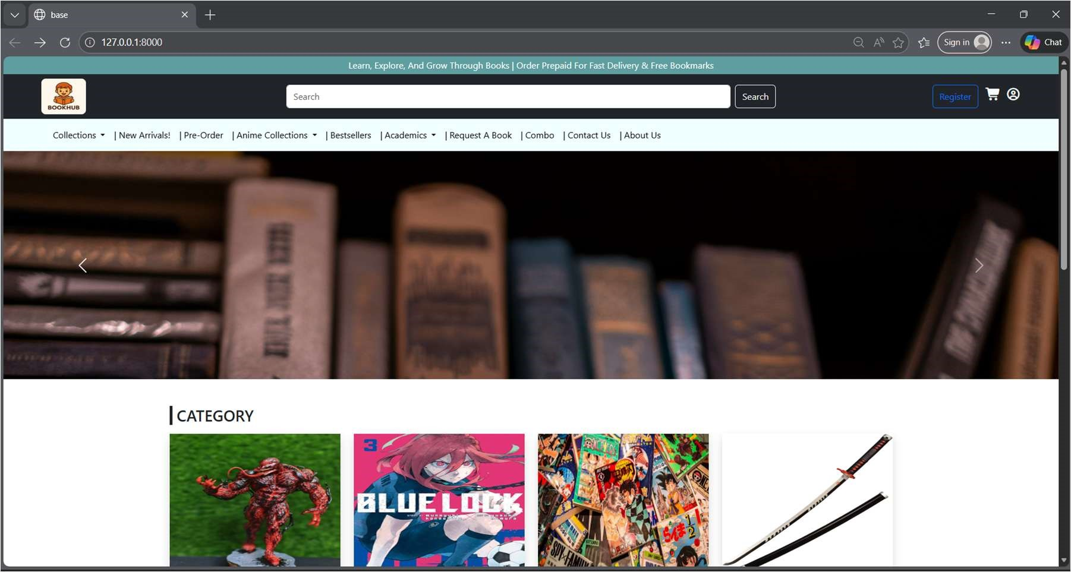
Fig 1. E.1 Home Page

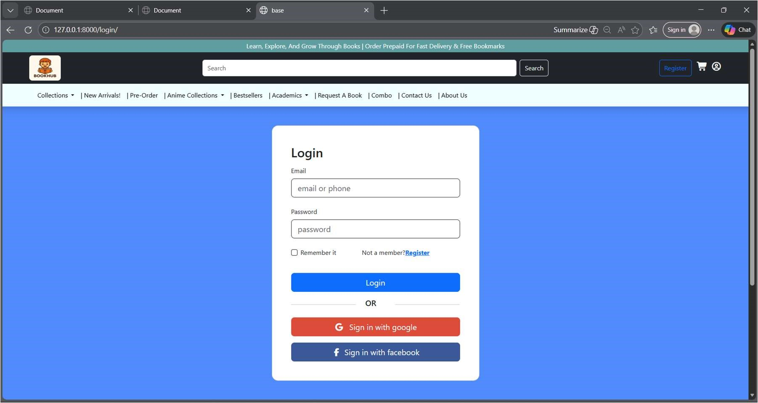
Fig 2. E.1 Login Page

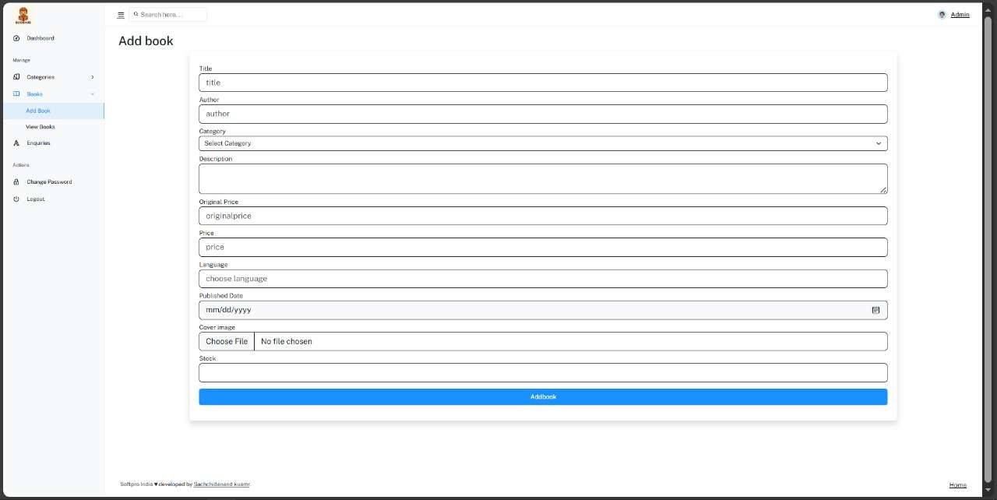
Fig 3. E.2 Book Listing Page

